**Govt. College Kharkhara**

**Code of Conduct for Students**

➢ All the students should get their Identity Cards made from the college Library after their admission. It should be signed by the Principal of college. Students must wear their Identity Cards during their stay in the college. It is the duty of a student to show his/her Identity Card if demanded by the Principal or any other faculty member of the college. It should not be passed on to other students. In case of loss/damage/theft, a New Identity Card will be re- issued to a student only on a payment of Rs.50/- with the special permission of the Principal.

➢ Students must read the notice board daily before leaving the college to get information about instructions/ orders issued by the Principal from time to time.

➢ Student must remain in discipline and it is their moral duty to show respect towards their teachers and elders.

➢ Students are advised not to roam around in the verandahs or outside the classrooms under any circumstances so as to avoid disturbance in teaching.

➢ If any student is found violating any of the code of conduct or any other instructions displayed on notice board from time to time, the Principal will have the right to suspend/ terminate the student from the college.

➢ Smoking and use of drugs in the college campus is a punishable offence.

➢ Student are expected to protect college property and maintain the beauty of the campus by their appropriate actions.

➢ Students are also advised not to sit on staircases to avoid inconvenience to others.

➢ If the teacher is on leave the students should go quietly to library and study books, newspapers/periodicals.

➢ Students are not allowed to bring/invite outsiders in the college premises.

➢ Boys should show courtesy to let the girls enter and leave the classes first as the period begins and ends.

➢ It is mandatory for all the students to be present in the college functions.

➢ If a student absent from class five rupees per day fine will be imposed.

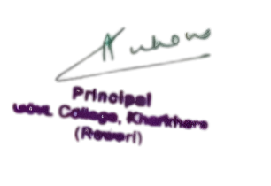

**Principal**